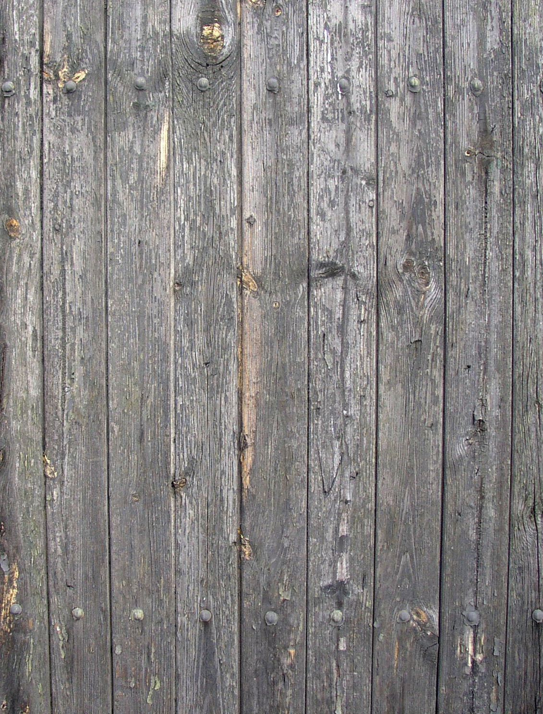

Drinks List

|  |  |  |
| --- | --- | --- |
| **On Tap Now** | **alc** |  |
| **Speight's** |  |  |
| Gold Medal Ale | 4.0% | 12.5 |
| Summit | 4.0% | 12.5 |
| Triple Hop Pilsner | 4.0% | 12.5 |
| Old Dark | 4.0% | 12.5 |
| Speight’s Apple Cider | 4.6% | 14.5 |
| Speight’s Hazy Pale Ale | 4.5% | 15.5 |
| **Emersons** |  |  |
| Super Quench (Pacific Pilsner) | 4.0% | 15.5 |
| Green Thumbs (XPA) | 4.87% | 15.5 |
| London Porter | 5.0% | 15.5 |
| **Mixed Spirits on Tap** |  |  |
| Bloody Shiraz Gin Spritz | 7.0% | 14.5 |
| Zeffer Lemonade | 5.0% | 15.5 |
| **Bottled Beers** |  | **bottle** |
| Speight’s Mid Ale | 2.5% | 9.5 |
| Speights Summit Zero | 0.0% | 10 |
| Steinlager Classic | 5.0% | 9 |
| Steinlager Pure | 5.0% | 9 |
| Steinlager Light | 2.5% | 9 |
| Corona | 4.5% | 12 |
| Stella Artois | 5.0% | 12 |
| **Cider** |  |  |
| Zeffer Cider: Passionfruit | 5.0% | 12.5 |
| Speight’s Cider: Apple | 4.6% | 14.5 |
|  |  |  |
| **Ginger beer - Alcoholic** |  |  |
| Mac’s Ginger Giant | 5% | 14.5 |
|  | | 9 |
| **Gin** | |  |
| Gordons: London Dry | Pink | | 13/13 |
| Bombay: Sapphire | Bramble | | 14 |
| 42 Below | | 14 |
| Grey Goose | | 14 |
| Malfy: Original | Orange| Limone| Rosa | | 14 |
| Tanqueray: London Dry| 10 | Roots | | 14/15/15 |
| Sevi'lla &Rangpur |Roku | Juno | | 16//18/18 |
| **Bourbon** | |  |
| Wild Turkey: Original |Honey | | 13/13 |
| Jack Daniels | Bullet | | 13/14 |
| **Rum** | |  |
| Barcardi |Coruba | | 13 |
| Appletons: Signature |12 yr | 21 yr | | 13/14/16 |
| **Whiskey** | |  |
| John Walker: Red |Black | | 13/14 |
| Bushmills: Blackbush | 10 yr | | 13/14 |
| Glenfiddich 12 yr | Dimple | Markers Mark | | 13/14/14 |
| Crown Royal |Caol Ila | Lagavulin | | 15/16/24 |
|  | |  |
|  | |  |

**Bubbles glass / bottle**

|  |  |
| --- | --- |
| Lindauer  Brut | Sauv Blanc | Pinot Gris | Fraise | 12.5 |
| Prosecco Le Contesse | 12.5 /57 |
| Clearview Sparkling Blush | 13.5 62 |

**Chardonnay**

|  |  |
| --- | --- |
| Kopiko Bay | 12.5 /57 |
| Home Block Martinborough Vineyard | 13.5/62 |
| Spy Valley | 15.5 /70 |
| **Sauvignon Blanc** |  |
| Kopiko Bay | 12.5 /57 |
| The Ned | 14.5 /67 |
| Man O War Sidewinder | 15.5 /72 |
| **Pinot Gris** |  |
| Kopiko Bay | 12.5 /57 |
| The Ned | 14.5 /67 |
| Lake Hayes by Amisfield | 15.5 /72 |
| **Riesling** |  |
| Roaring Meg | 12.5 /57 |
| **Rose** |  |
| Kopiko Bay | 12.5 /57 |
| Wither Hills | 12.5 /57 |
| Clearview The Blush (Napier) | 14.5 /67 |
| **Merlot** |  |
| Kopiko Bay | 12.5 /57 |
| Clearview Cape Kidnappers | 13.5 /62 |
| **Syrah /Shiraz** |  |
| Metala Langhourne Creek | 13.5 /62 |
| Killibinbin | 14.5 /67 |
| **Pinot Noir** |  |
| Kopiko Bay | 12.5 /57 |
| Morton Estate | 13.5 /62 |
| Rabbit Ranch | 14.5 /67 |
| Lake Hayes by Amisfield | 18.5 /87 |
| **Red Blend** |  |
| Killibinbin Cab/Sav | 14 / 65 |
| Esk Valley Mer/Cab/Malbec | 14 / 65 |
|  |  |
|  |  |
| **Hot Drinks** |  |
| **Coffee** L'Affarre Short/ Long Black, Flat White Latte, Cappuccino, Mochaccino | 5.5 |
| Iced Coffee | 10 |

|  |  |
| --- | --- |
| **Tea** English Breakfast| Earl Grey| Japanese Lime Green | 5 |

|  |  |
| --- | --- |
| **Hot Chocolate** | 6 |
| **Iced Chocolate /Coffee** | 10 |
| **Sodas - Macs**  Feijoa Pear & Elderflower | Ginger beer | Lemon Crush | Tropical Passionfruit | 8 |
| A black and white image of a drink  Description automatically generated  BOMBAY BREEZE-$16  Bombay Sapphire, Cranberry,  Lemon, Soda    POOH BEAR-$16  Honey Vodka, Ginger Beer, Lemon    PASSIONARITTA-$19  Cuervo Jose Gold, Cointreau, Passionfruit, Lemon    ALE HOUSE PINK GIN-$16  Pink Gin, Soda, Lemonade, Mint, Raspberry    THE WHAKATIPU -$19  Feijoa Vodka, Lime, Cucumber, Egg White, Ch’i    ESPRESSO MARTINI -$19  Espresso, Vodka, Kahlua, Simple Syrup, Chocolate    ROSEBUD-$19  Vanilla Vodka, Cranberry, Pineapple, Passionfruit | | | A black and white logo  Description automatically generated  THE SPLICE OF LIFE-$20  Midori, Malibu,  Pineapple, Cream    DOUBLE ‘O SEVEN-$22  Bombay Bramble, Vermouth, Lemon,  Raspberry, Egg White, Prosecco  NON-ALCOHOLIC    SUMMER LIGHT-$10  Pomegranate Syrup, Mint, Ch’I    MOJITO SODA -$12  Mojito Mint Syrup, Mint,  Lime, Lemon, Soda  A black and white logo  Description automatically generated  JUICY CRUSH -$12  Apple juice, Cranberry, Orange Juice  Mint    VIRGIN ROSEBUD-$15  Cranberry, Pineapple, Passionfruit |

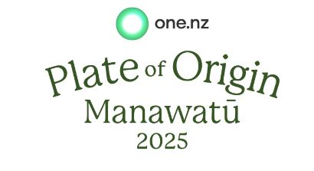

**Speight’s Ale House Palmerston North**

**Head Chef: Dwaynne Blackett**

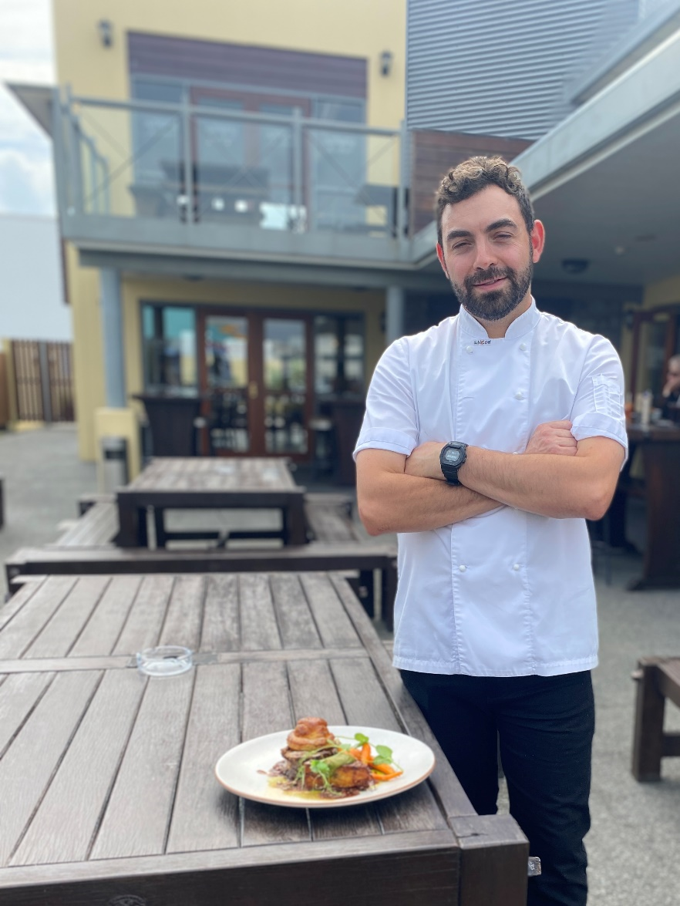

Judged

“Highly Commended”

By

Plate of Origin Judges

May 2025

**Heritage Lamb w Ploughman’s Pithvier**

braised lamb shoulder/ honey glazed baby carrots/ smoked cheese potato gratin / lamb ragu sauce / topped with a potato, mushroom smoked cheddar pithvier

**plateoforigin.co.nz**

**STARTERS TO SHARE**

# Garlic Bread Loaf | hot baked/ plain butter/garlic butter. Half 10 Whole 18.0

# Edamame Bean Bowl | steamed edamame beans, seasoned w salt & pepper 16.0

# Pan Fried Chicken Dumplings | house-made chicken dumplings / soy sauce 16.0

# Baked Camembert | baked camembert wheel / caramelised cinnamon apples / bacon walnut praline / toasted ciabatta 25.0

# Moeraki Mussels | green-lipped mussels/ thai green curry sauce/ grilled ciabatta bread. 26.0

# Salt and Pepper Calamari | salt and pepper panko crumbed with lime and chipotle mayo 20.0

# Ale House Pate | chicken pate/ port jelly/ toasted ciabatta bread. 25.0

## **Bluff Chowder** | homemade clear stock/ assorted fish fillets/ shellfish/ bacon/ vegetables/ fennel/ dill 20.0

**SALADS & PASTA**

# Caesar Salad | cos lettuce/ bacon/ anchovies/ croutons/ parmesan cheese/ parmesan cheese dressing and poached egg. 27.0

# Shamrock Chicken Salad | moroccan chicken/ spiced Israeli couscous/ salad/ avocado/ grapes/ cumin yoghurt dressing. 30.5

**Thai Beef Salad** | marinated thai beef/ salad/ roasted cashews/ crispy noodles/ thai beef salad dressing. 30.5

**Goats Cheese Salad** | goat’s balls (cheese) / spiced Israeli couscous/ salad/ avocado/ grapes/ cumin yoghurt dressing. 30.5

## **Pasta of the Day** | chef’s creation each day. Please ask our staff for details 30.5

**BURGERS & LIGHT MEALS**

**Castle Street Chicken Burger** | crispy chicken/ bacon/ caramelised onions/ cheese/ tomato/ lettuce/ japanese mayo/ fries. 30.5

**The Vege Burger** | quinoa/chickpea burger patty/ beetroot relish/ cheese/ courgette/ red pepper/ cumin yoghurt dressing/ fries 28.0

**Cardrona Beef Burger** | homemade beef patty/ bacon/ egg/ cheese/ beetroot relish/ lettuce/ tomato/ caramelised onions /fries 30.5

**Ophir Corn Fritters** | corn fritters/ bacon/ salad greens/ tomato/ coriander salsa/ sour cream and sweet chilli sauce. 28.5

**Grandma’s Lambs Fry** | lamb’s liver/ bacon/ caramelised onions/ gravy/ potato mash. small 25.0 large 30.5

**James Speight’s Porter Sausage & Mash** | porter sausages/ potato mash/ peas/ caramelised onion gravy small 25.0 large 30.5

## **Beef Schnitzel** | crumbed beef schnitzel/ fries/ salad/ Ale House Gravy or mushroom sauce. 33.8

**SPEIGHT’S ALE HOUSE CLASSICS**

**Southern Man’s Breakfast** | fried eggs/ bacon/ sausage/ mushrooms/ grilled tomato/ bubble and squeak 29.0

**Blue ‘n’ Gold** | battered Southland Blue Cod**/** iceberg lettuce//buttermilk dressing/ fries/ tartare sauce. & tomato sauce 42.5

## **Market Fresh Fish of the Day** | chef’s creation for today’s fresh catch. Please ask our staff for details 36.5

## **Cherry Chicken** | pan roasted chicken supreme/ herb stuffing/ bacon wrapped/ kumara mash/pumpkin 38.5 fresh cherry olive salsa/cherry pan sauce.

## **Confit Pork Belly** walnut apple sausage roulade/ mustard fruits / roasted kumara / braised red cabbage / cider jus 42.0

**The Shearer’s Lamb Shank** | braised lamb hind shank/ potato mash/ seasonal vegetables/ gravy/ mint glaze 42.0

**Frank Oliver’s Spareribs** | slow roasted pork spareribs/ BBQ sauce/ salad/ spicy wedges small 38.0 large 48.0

**Plate of Origin: Heritage Lamb w Ploughman’s Pithiver** | braised lamb shoulder/ honey glazed baby carrots/ 48.0

smoked cheddar potato gratin / lamb ragu sauce / topped with a potato, mushroom smoked cheddar pithvier

**GRILL SECTION**

**The Stockman’s Steak** | 300g Angus Pure Rump/ fries / salad greens/ with either mushroom sauce / 300g Rump 40.0

roasted garlic butter /green peppercorn sauce

**The “Boucher’s” Cut**  | 300g Angus Pure Scotch Fillet or Porterhouse/ mustard potato mash/ 300g Porterhouse 50.0

beer-battered onion rings/ bearnaise sauce and with house-made beef jus 300g Scotch Fillet 55.0

**SIDES**

# steam vegetables | with butter and parsley 7.0

# green beans | with butter and toasted almonds 7.0

# creamy mash potato 8.0

# caesar side salad | cos lettuce/ crouton/ parmesan/ anchovy bacon with caesar dressing 7.0

**DESSERTS**

### **Crème Brulèe** | /creamy baked vanilla custard / caramelised sugar / seasonal fruit compote 17.0

### **Farmhouse Cheesecake** | cheesecake/Ask for today’s selection. 17.0

### **Baby Pavlova** | fresh fruit/ whipped cream/ ice cream/ passionfruit syrup. 16.0

### **Hot Chocolate Chip Skillet Biscuit** | freshly baked/ served with ice cream/peanut chocolate sauce. 16.0

### **Sticky Date Pudding** | salted butterscotch sauce/ ice cream. 16.0

### **Boysenberry Knickerbocker Glory** |boysenberries/ vanilla ice cream/ meringue/ and cream. 16.0

### **Mrs Brown’s Cinnamon Oysters** | two small/ feather-light cinnamon sponge cakes/ cream filled. 8.0

**Whiskey Coffee** | irish/ highland / drambuie /baileys 14.0

**Baileys & Hot Chocolate** 14.0

**WEE MATES MEAL DEAL**

**Main, Dessert, & Drink**

**$16.00**

**(T&C’s: Must be 12 years or younger)**

**W.M. MAINS**

## **Wee Ones Platter** | grapes/ carrots/ oranges/ raisins/ kiwifruit/ sliced ham/ rice crackers and cheese

## **Fish & Chips** | battered Southland blue cod/ fries

## **Crumbed Chicken** | crumbed chicken/ fries

## **Junior Burger & Chips** | all beef patty/ cheese/ lettuce/ tomato/ fries.

## **Battered Hotdog & Chips** | mini battered hotdogs/ fries

## **BBQ Pork Spare Ribs & Chips** | spare ribs/ BBQ sauce/ fries

## **Speight’s Ale House Sausage & Mash** | potato mash/ peas/ onions/ sausages/ gravy

**W.M. DESSERT**

## **Half Pint Ice Cream Sundae** | vanilla ice cream| selection of lollies /your choice of/ berry/ chocolate/ caramel sauce/ cream. 10

